**System and Software Architecture Description (SSAD)**

**Pic Share App (RA)**

**Team 1**

**Logan Chang – Project Manager, Developer**

**Zhou Jiashun – Developer**

**Yew Hua Chua – Developer**

**Haihao Lu – Developer**

**Yunwei Yuan – Developer**

**Yao Wang – Developer**

**Weili Zhang – Developer**

**Joseph Mouawad – Developer**

**Nicholas Funk – Developer, Quality Assurance Tester**

**27 April** **2016**

**Table of Contents**

1. Domain Model & Use Case Diagram 3

1.1 Domain Model 3

1.2 Use Case Diagram 4

2. Robustness Diagram 5

2.1 Navigation Robustness Diagram 5

2.2 Event Robustness Diagrams 6

2.3 Photo Management Robustness Diagram 10

2.4 Search Robustness Diagram 15

2.5 Profile Robustness Diagram 16

2.6 System & Administrator Robustness Diagram 18

3. Class diagram 20

4. Sequence Diagrams 21

4.1 Navigation Sequence Diagram 21

4.2 Event Sequence Diagram 21

4.3 Photo Sequence Diagram 26

4.4 Search Sequence Diagram 30

4.5 Profile Sequence Diagram 32

4.6 System & Administrator Sequence Diagram 35

5. Deployment diagram 37

# Domain Model & Use Case Diagram

## Domain Model

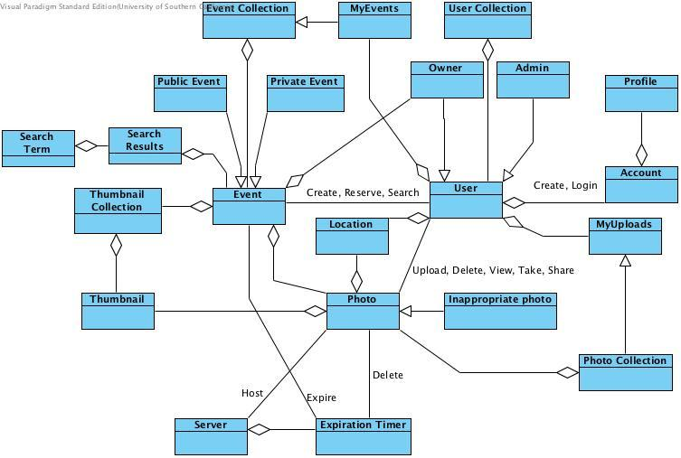

## Use Case Diagram

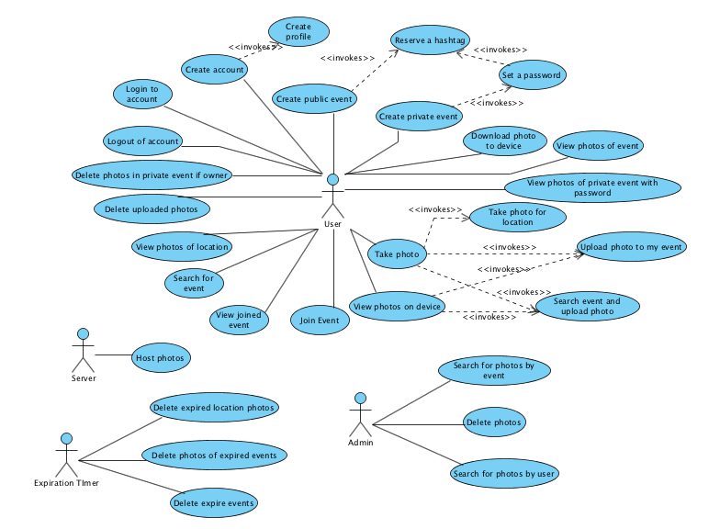

# Robustness Diagram

## Navigation Robustness Diagram

**Use Case: Navigate between screens**

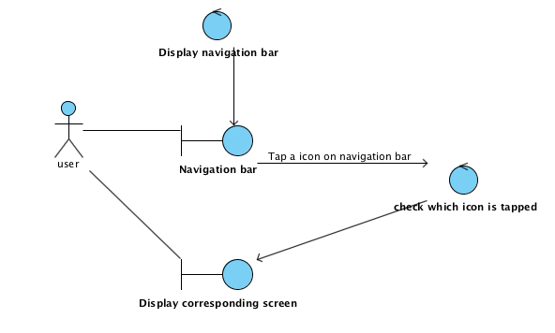

## Event Robustness Diagrams

**Use Case: Create a public event**

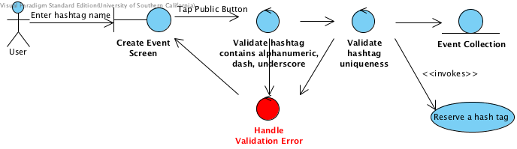

**Use Case:** **Create a Private Event**

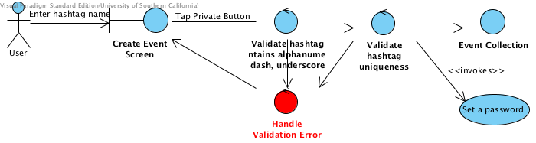

**Use Case:** **Set a Password**

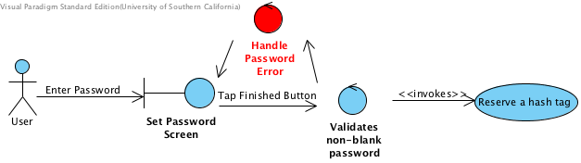

**Use Case:** **Reserve a Hashtag**

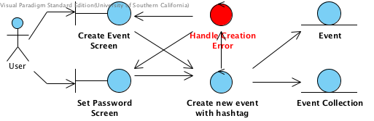

**Use Case:** **View photos of event/View photos of private event with password**

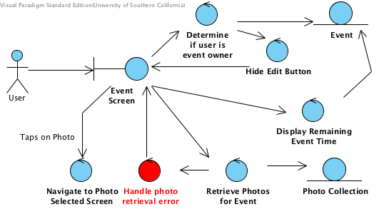

**Use Case: Download Photos to Device**

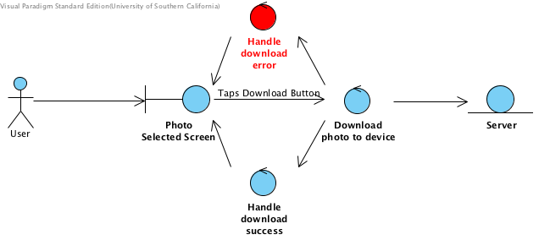

**Use Case: Delete Photos in Event if Owner**

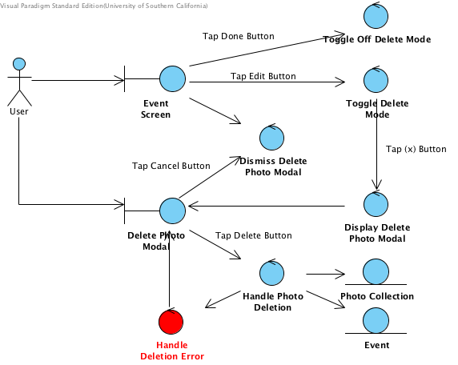

**Use Case: Join event**

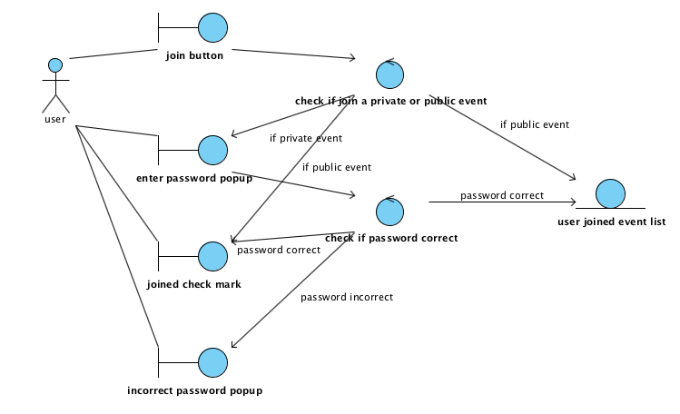

**Use Case: View joined Events**

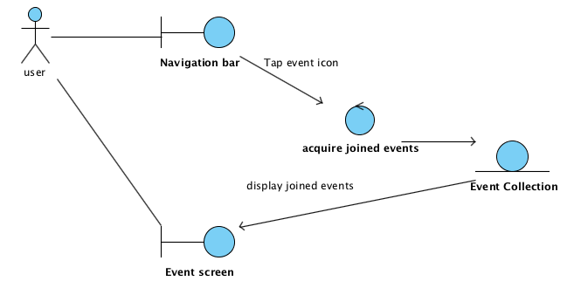

## Photo Management Robustness Diagram

**Use Case: Take a photo**

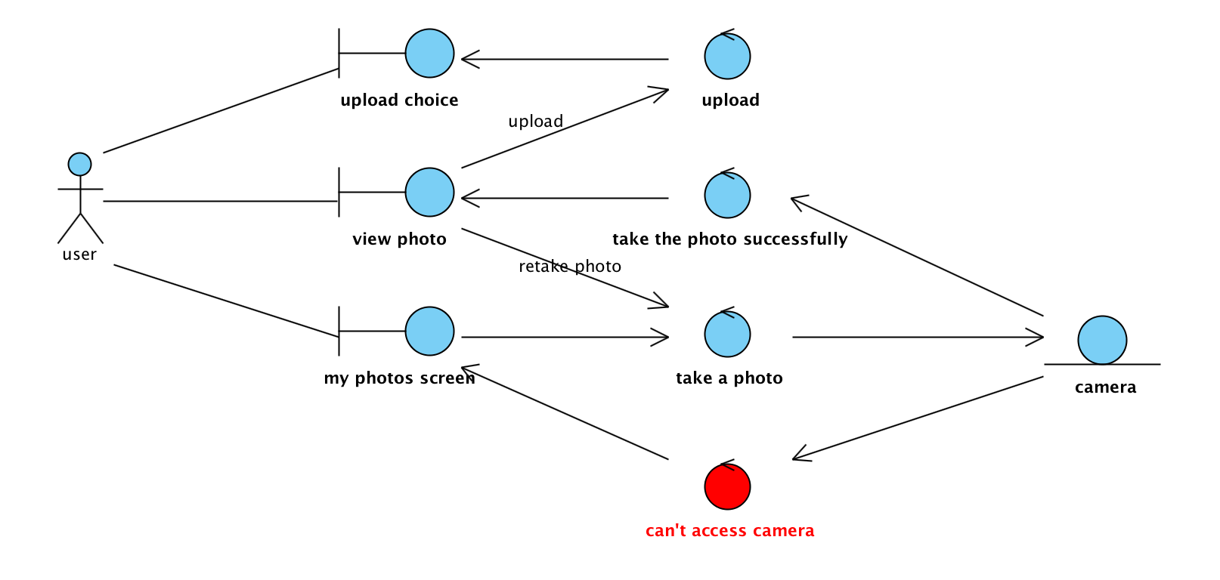

**Use Case: View photos on device**

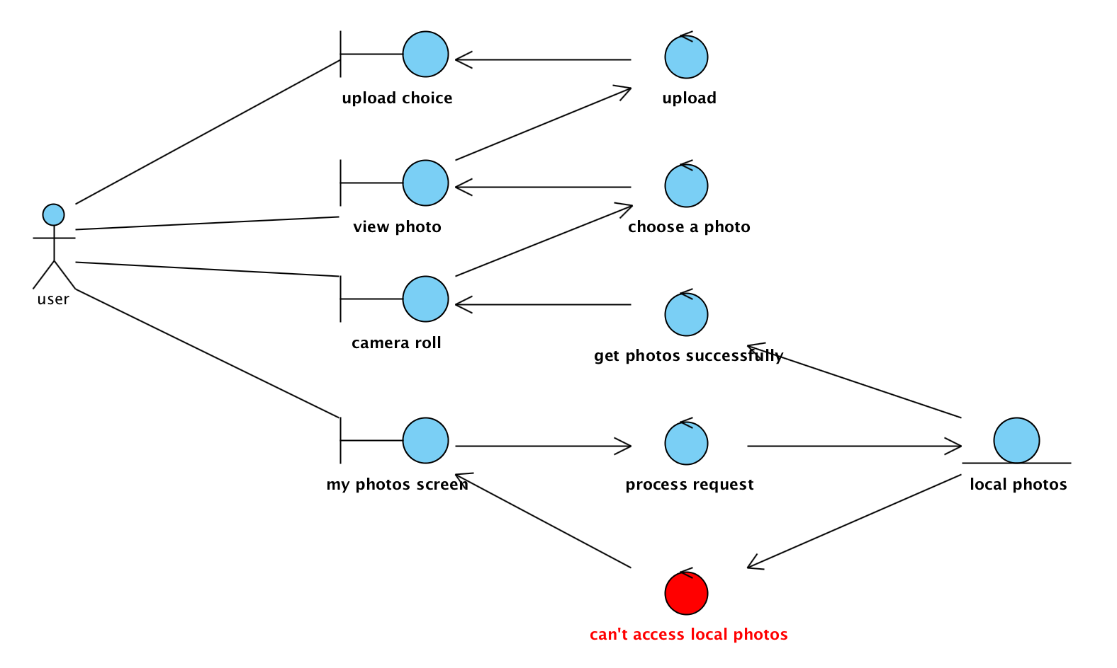

**Use Case: Upload photo to my event**

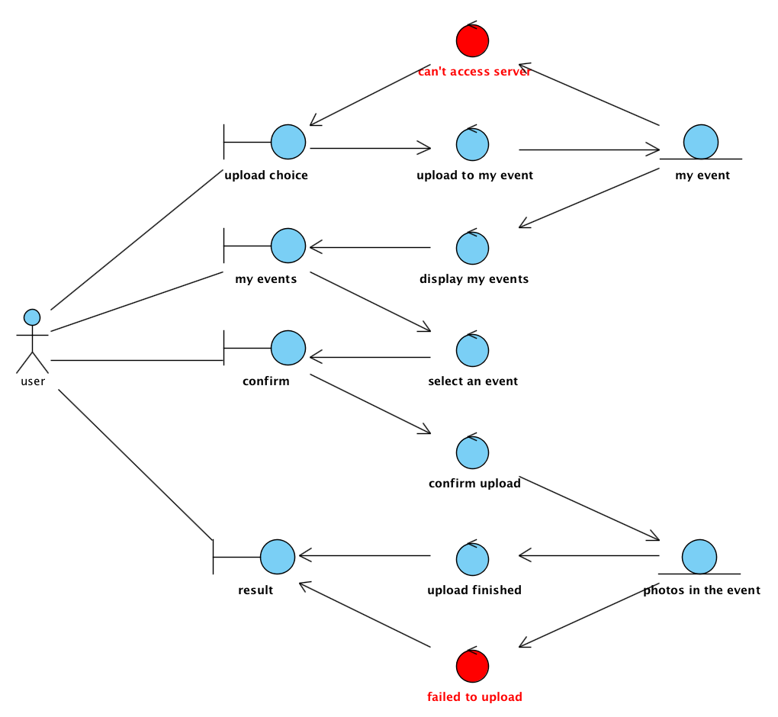

**Use Case: Search event and upload photo**

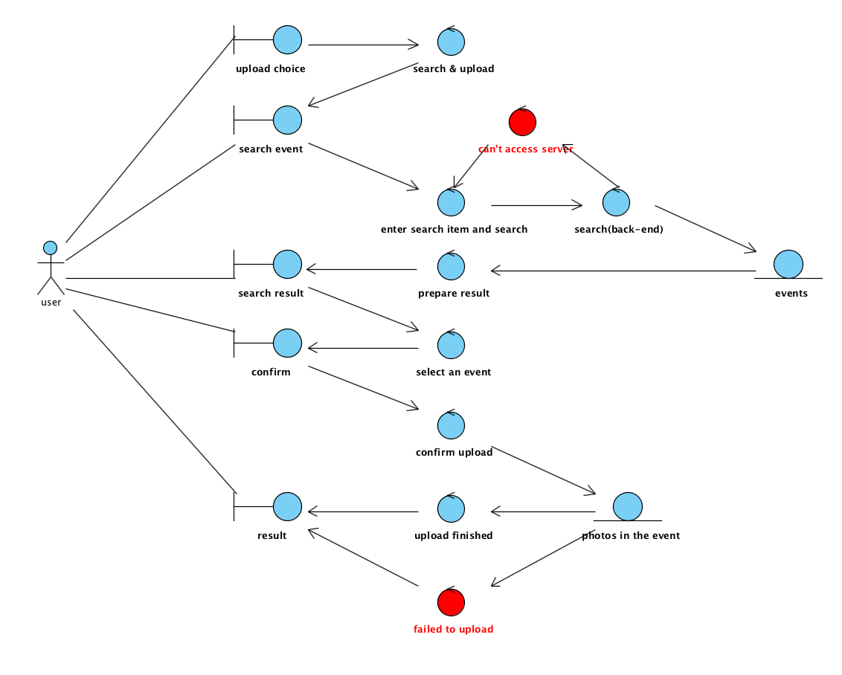

**Use Case: Upload photo to location**

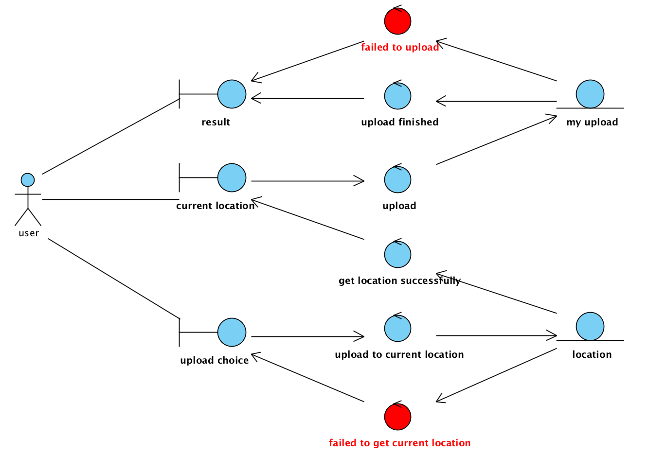

**Use Case: Delete uploaded photos**

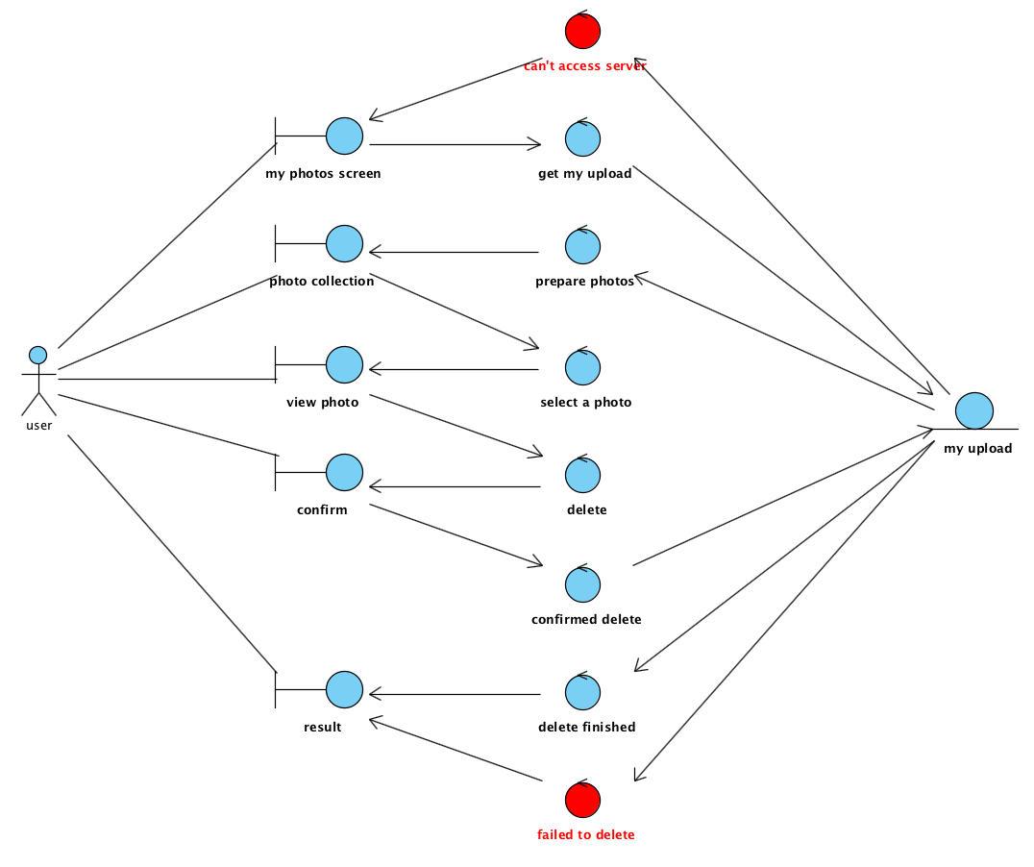

## Search Robustness Diagram

**Use Case: Search for event:**

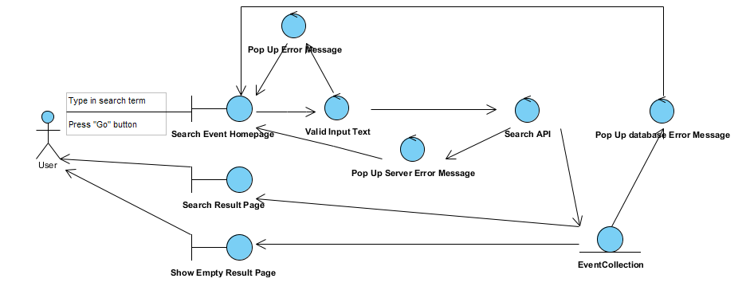

**Use Case: View photos of Location:**

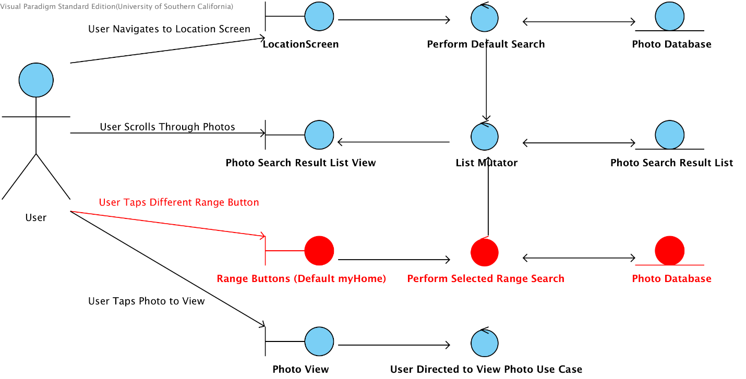

## Profile Robustness Diagram

**Use Case: Create account**

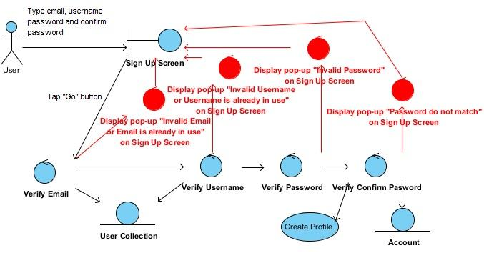

**Use Case: Create profile**

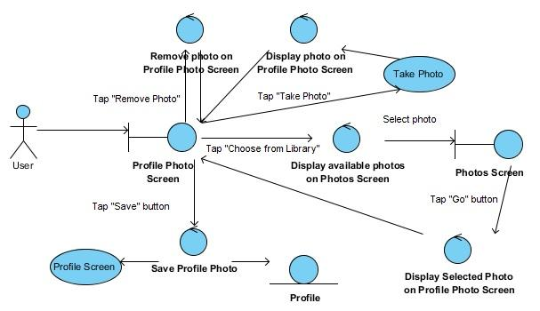

**Use Case: Login to account**

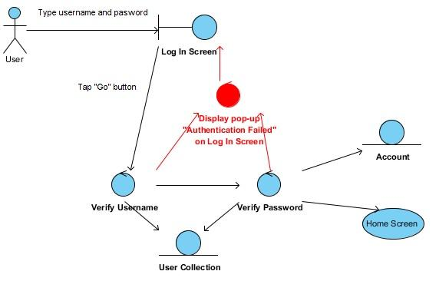

**Use Case: Logout of account**

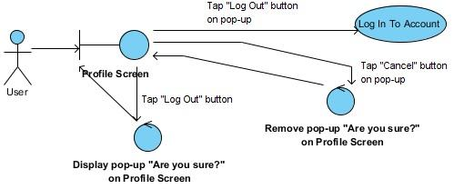

## System & Administrator Robustness Diagram

**Use Case: Admin search for photo by user**

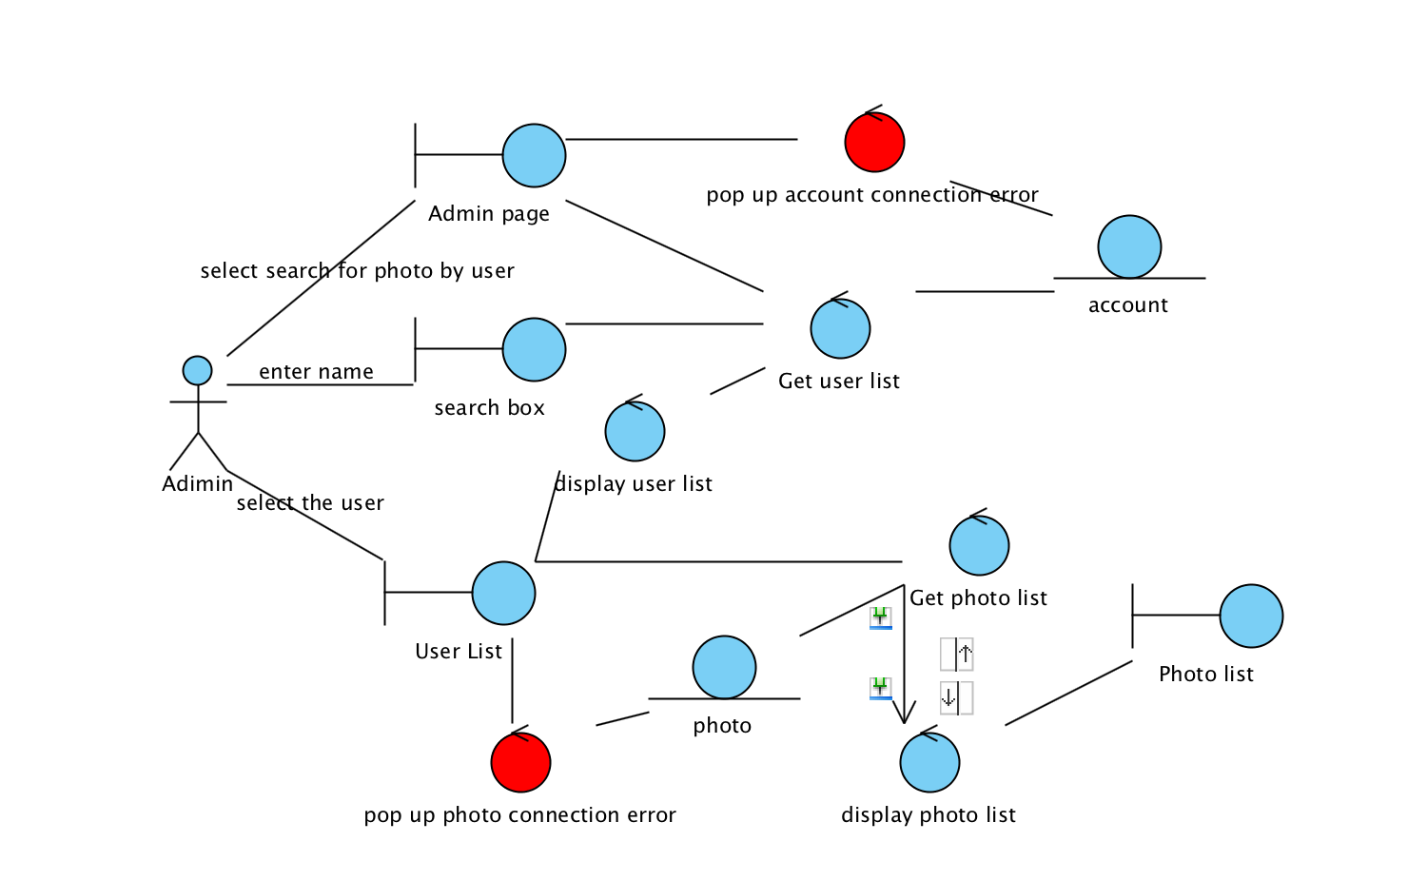

**Use Case: Admin search for photo by event**

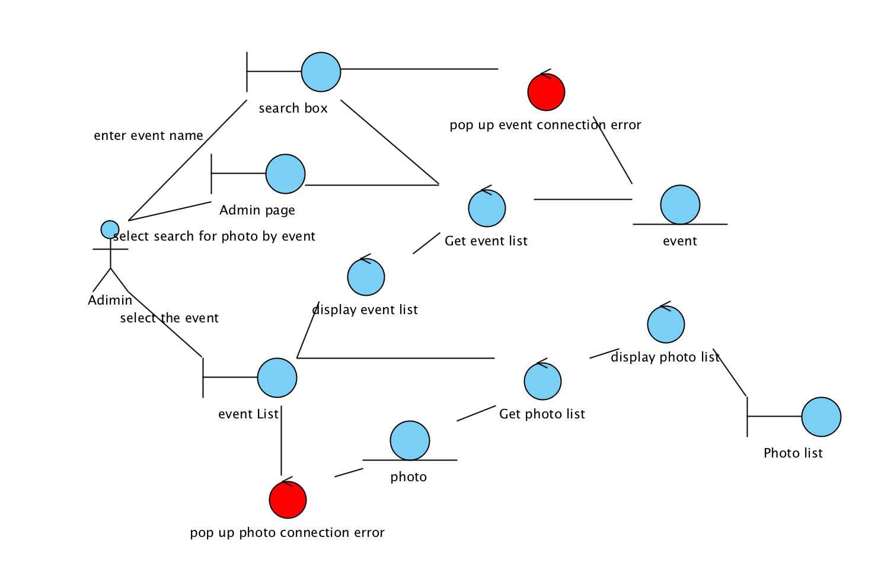

**Use Case: Admin delete photo**

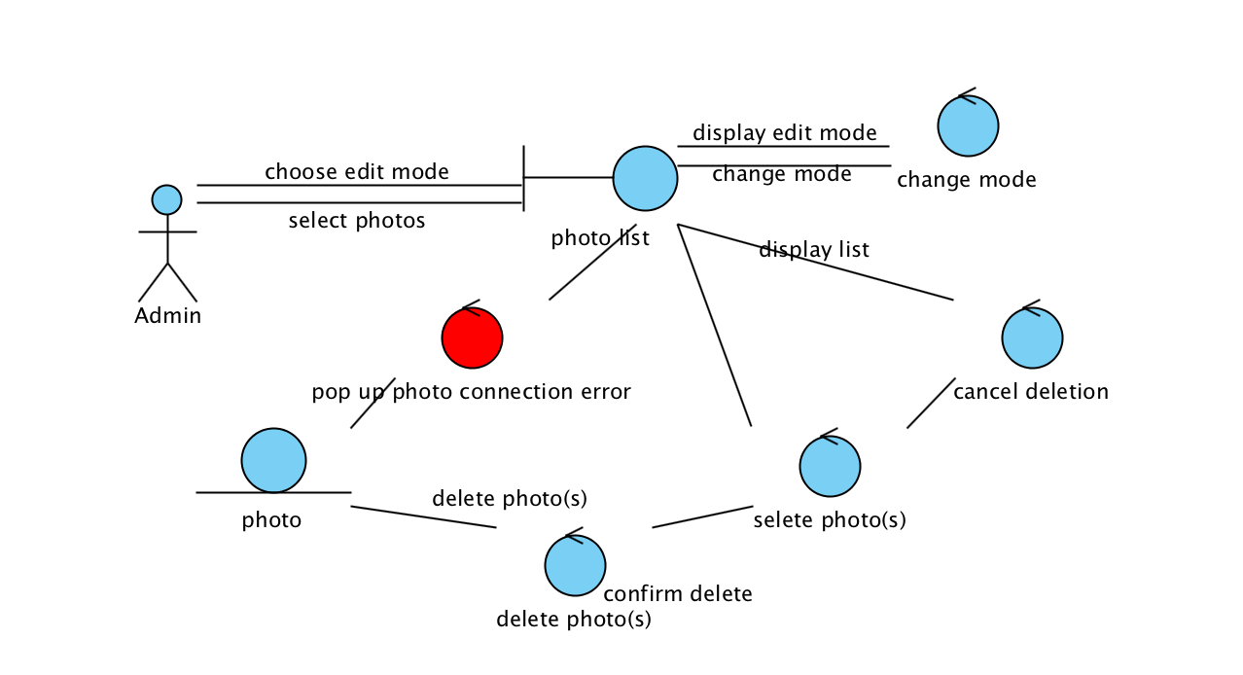

**Use Case: Automatic deletion**

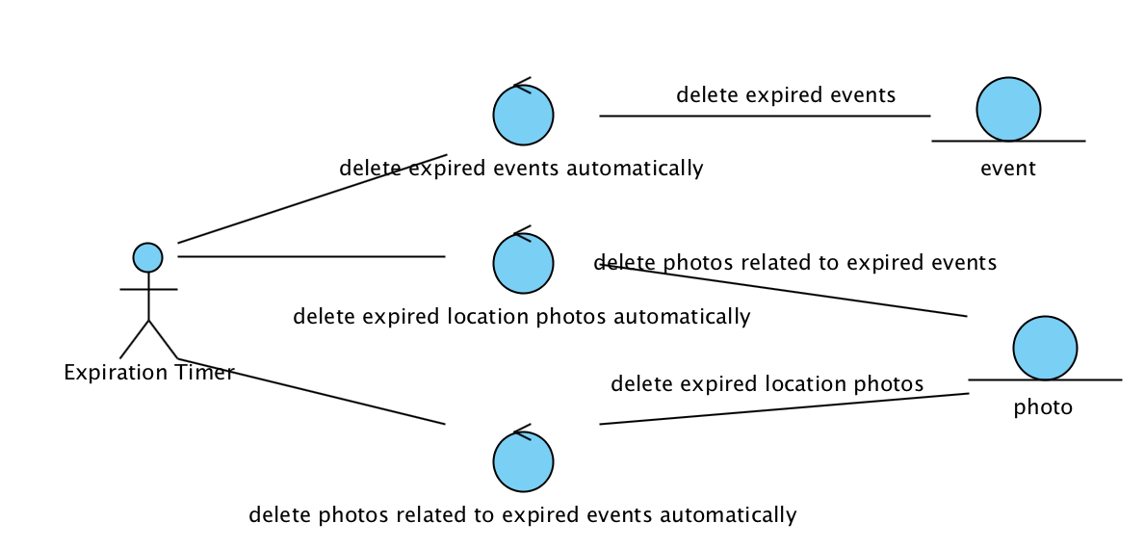

# Class diagram

# Sequence Diagrams

## Navigation Sequence Diagram

**Use Case: Navigate between screens**

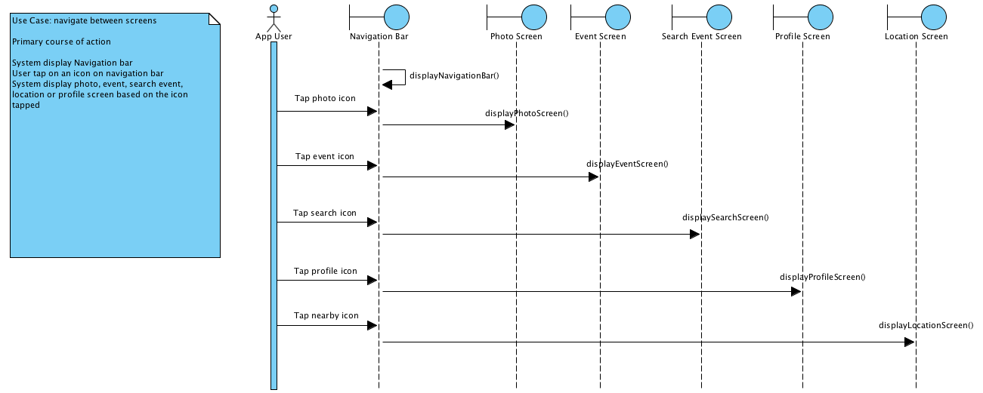

## Event Sequence Diagram

**Use Case: Create a pubic event**

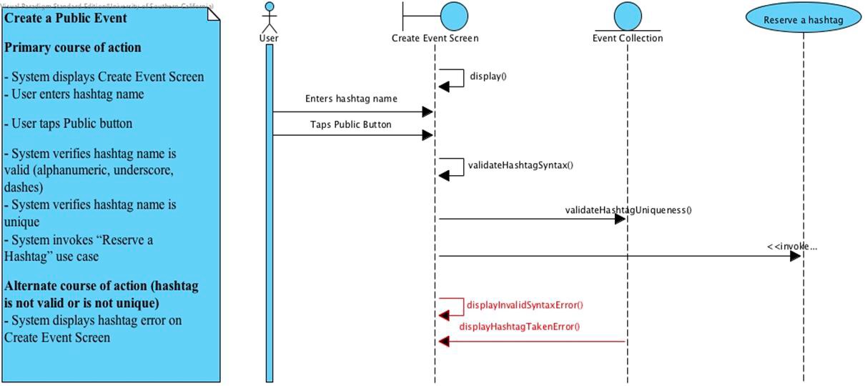

**Use Case: Create a private event**

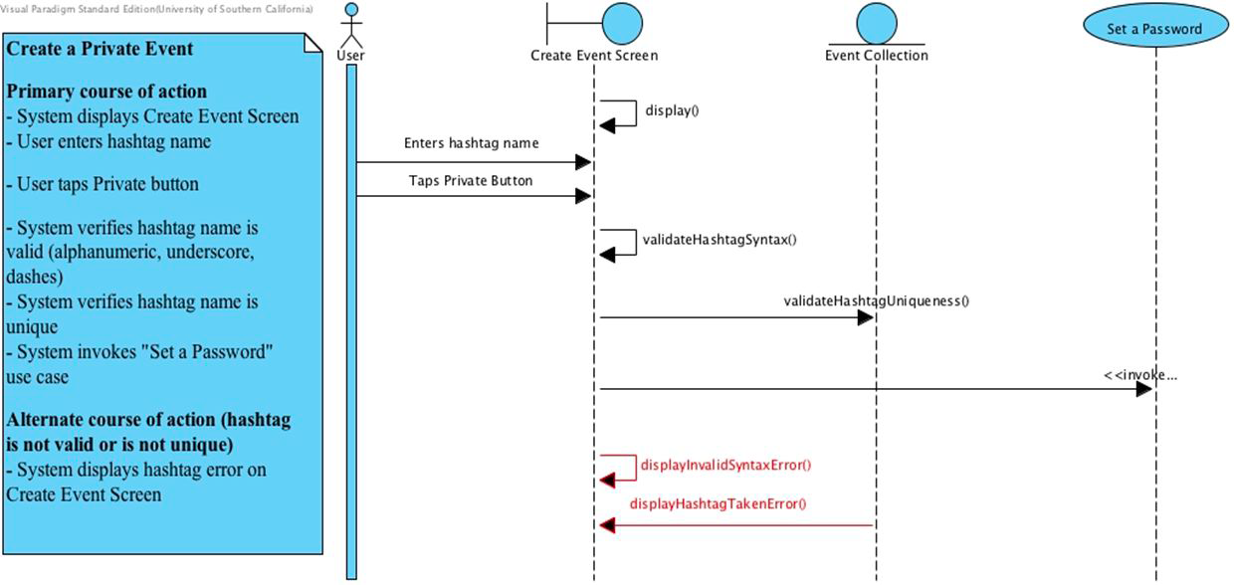

**Use Case: Set a password**

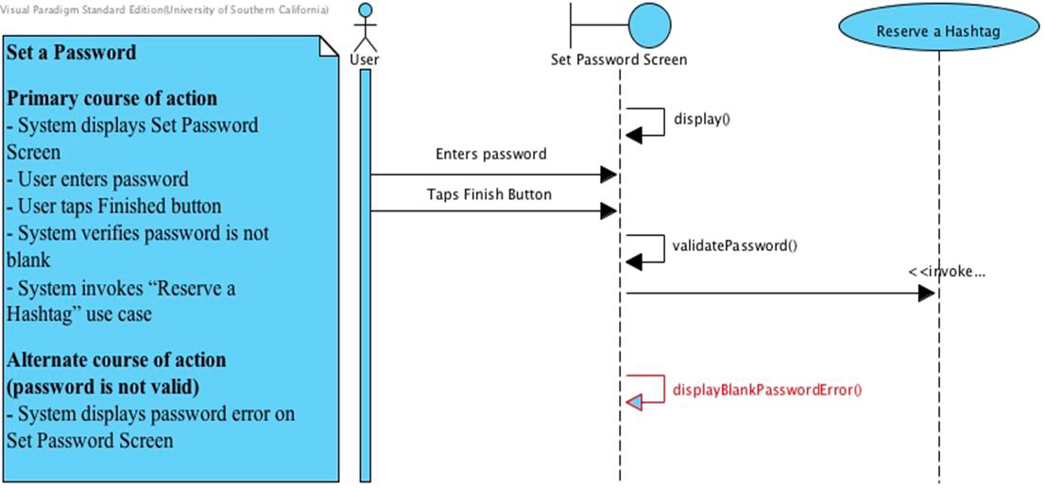

**Use Case: Reserve a hashtag**

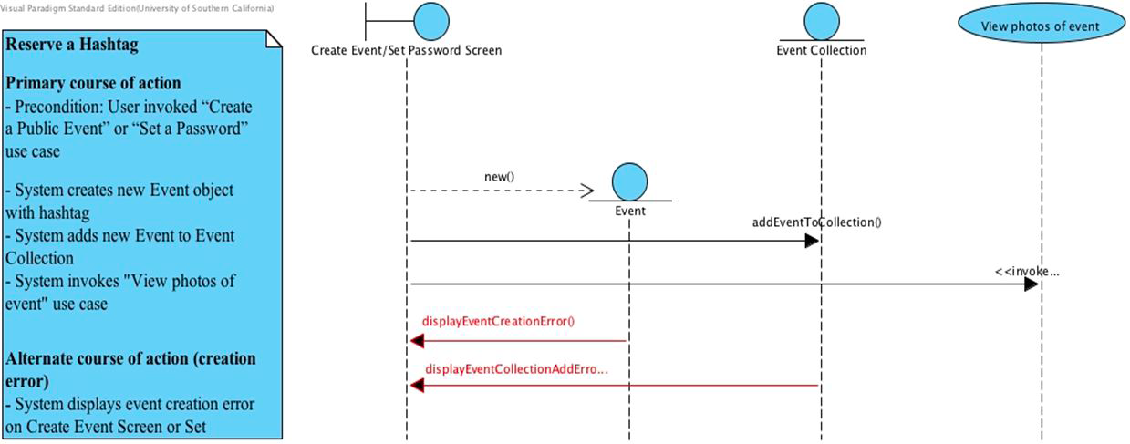

**Use Case: View photos of event/View photos of private event with password**

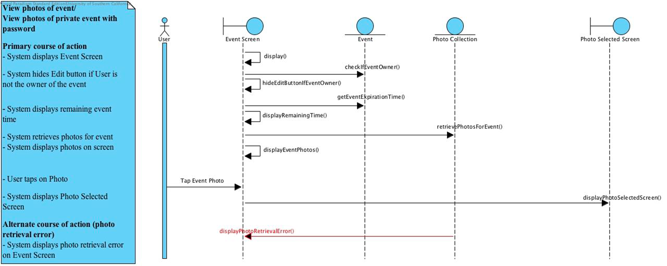

**Use Case: Download photos to device**

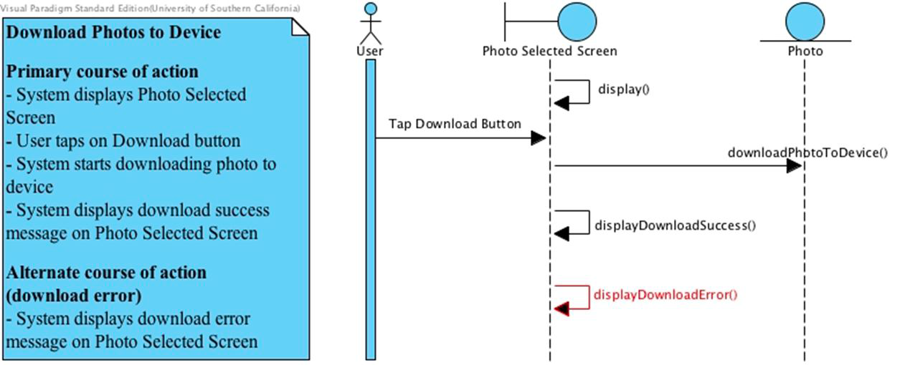

**Use Case: Delete photos in event if owner**

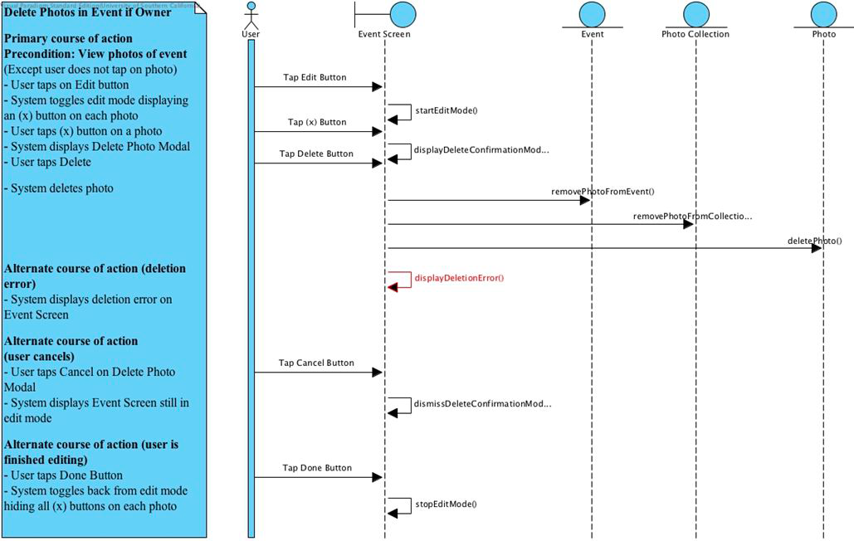

**Use Case: Join event**

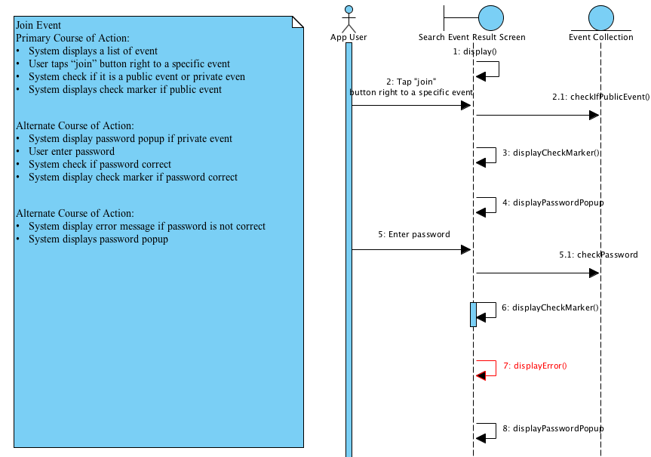

**Use Case: View joined events**

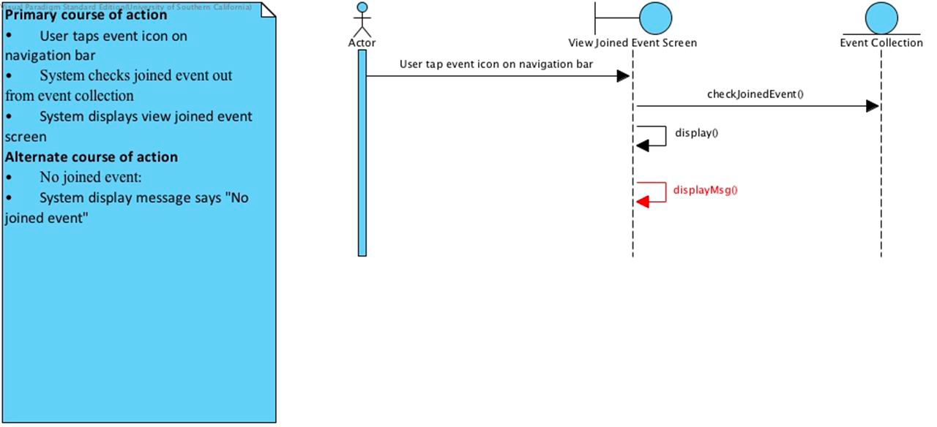

## Photo Sequence Diagram

**Use Case: Take a photo**

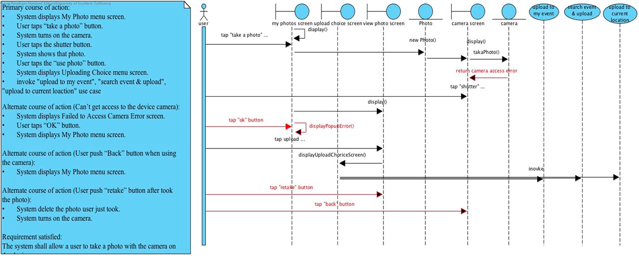

**Use Case: View photos on devices**

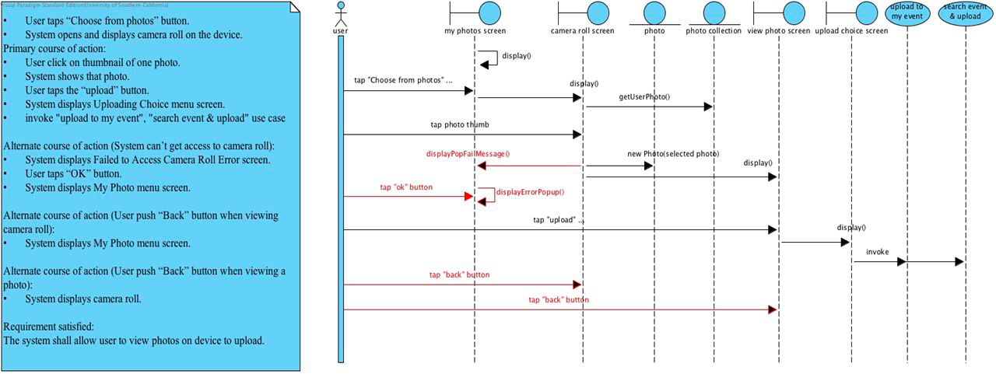

**Use Case: Upload photo to event**

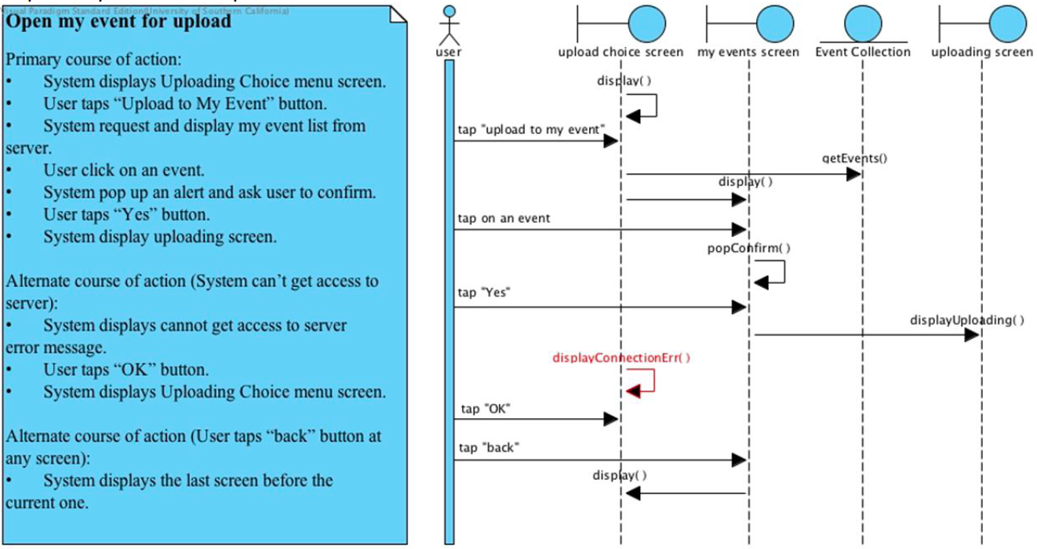

**Use Case: Search for event**

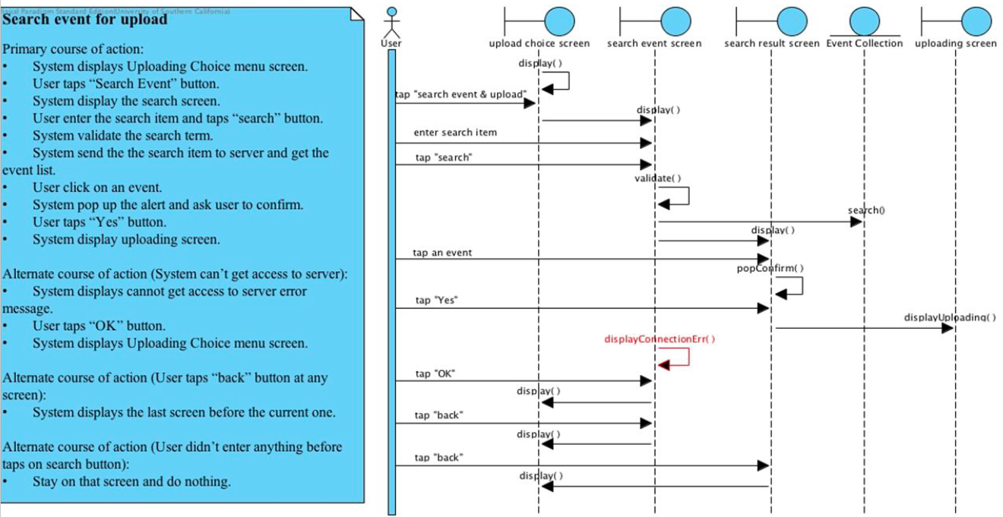

**Use Case: Upload to event**

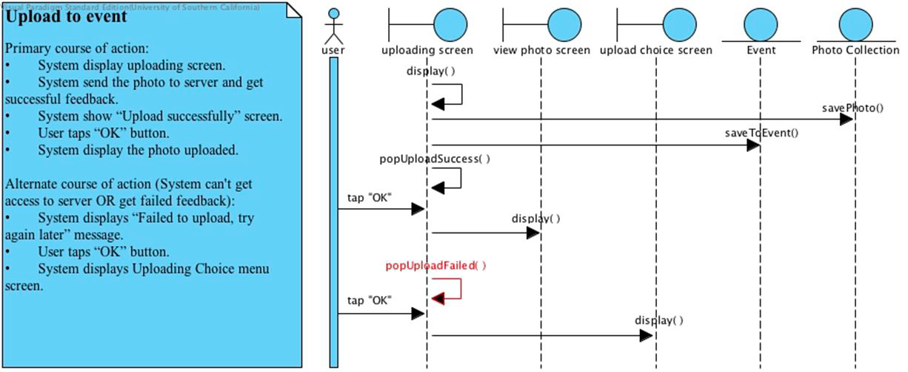

**Use Case: Upload photo to location**

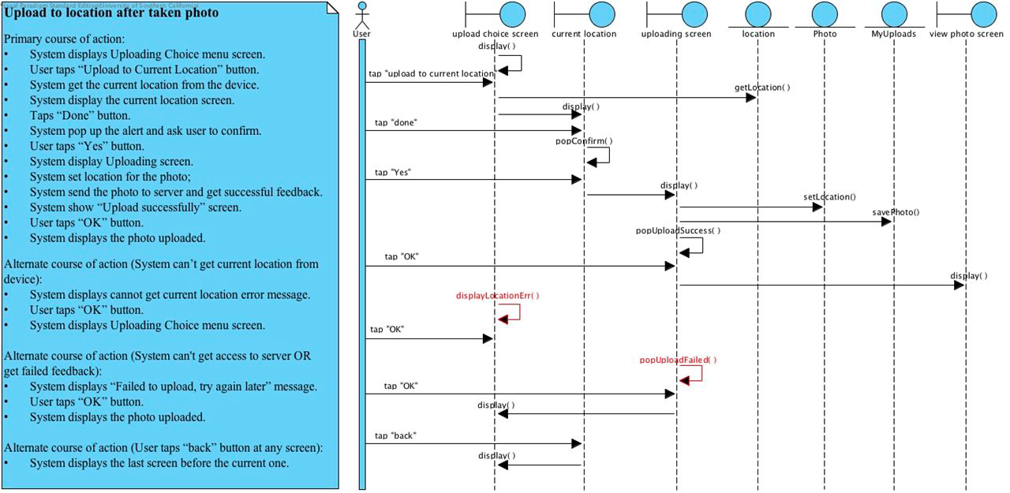

**Use Case: Delete uploaded photos**

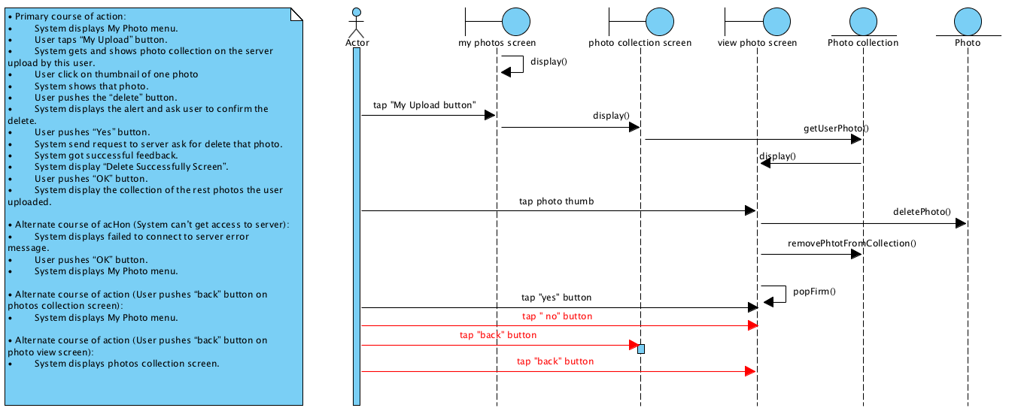

## Search Sequence Diagram

**Use Case: Search for event**

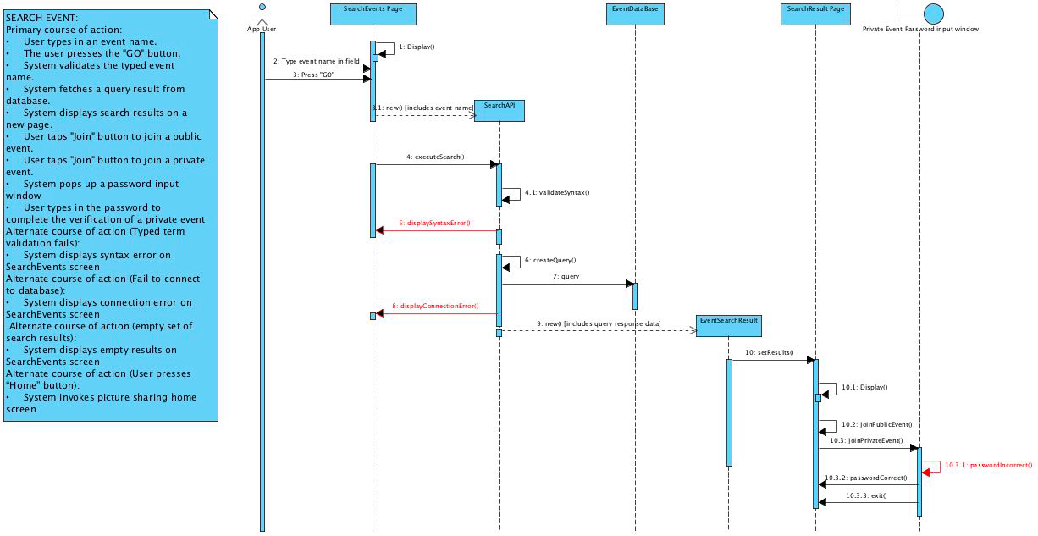

**Use Case: Search photos by location - Primary course of action**

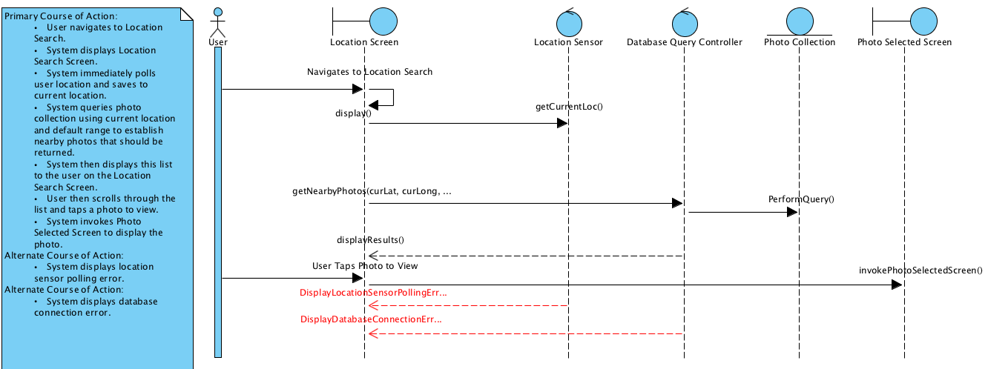

**Use Case: Search photos by location - Alternate course of action**

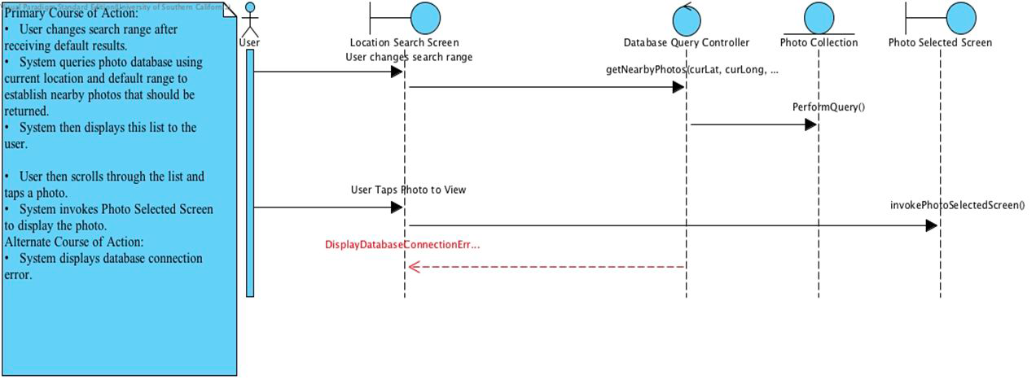

## Profile Sequence Diagram

**Use Case: Create account**

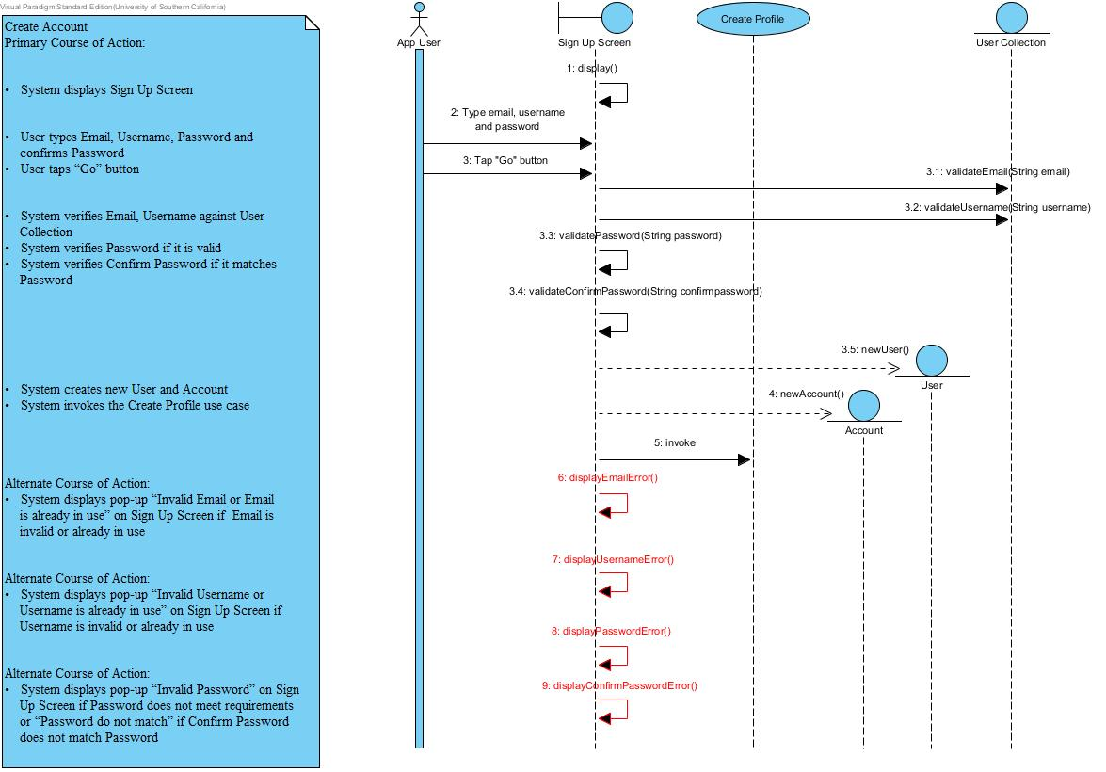

**Use Case: Create profile**

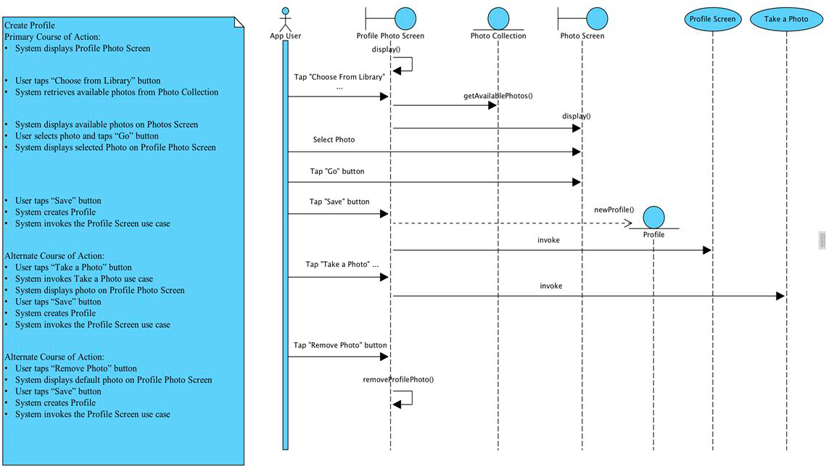

**Use Case: Login to account**

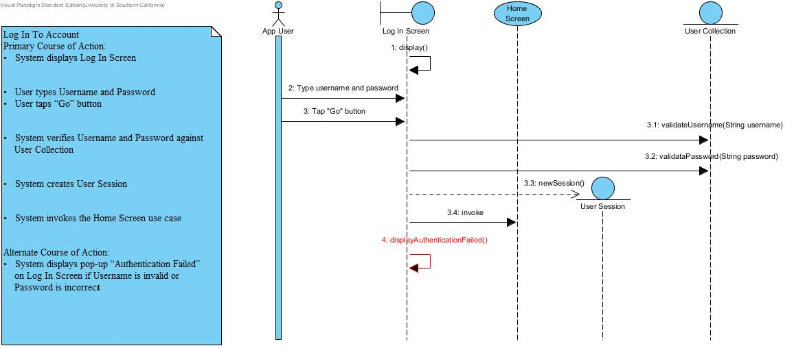

**Use Case: Logout of account**

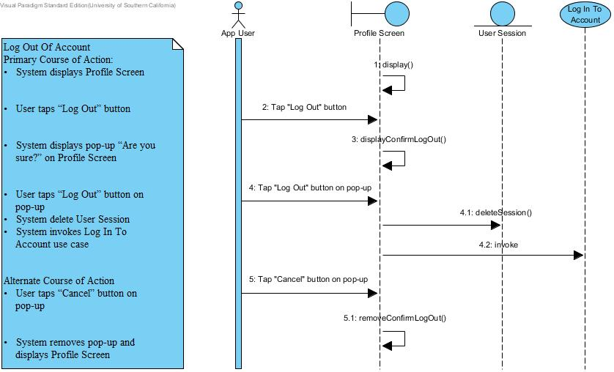

## System & Administrator Sequence Diagram

**Use Case: Admin search for photo by user**

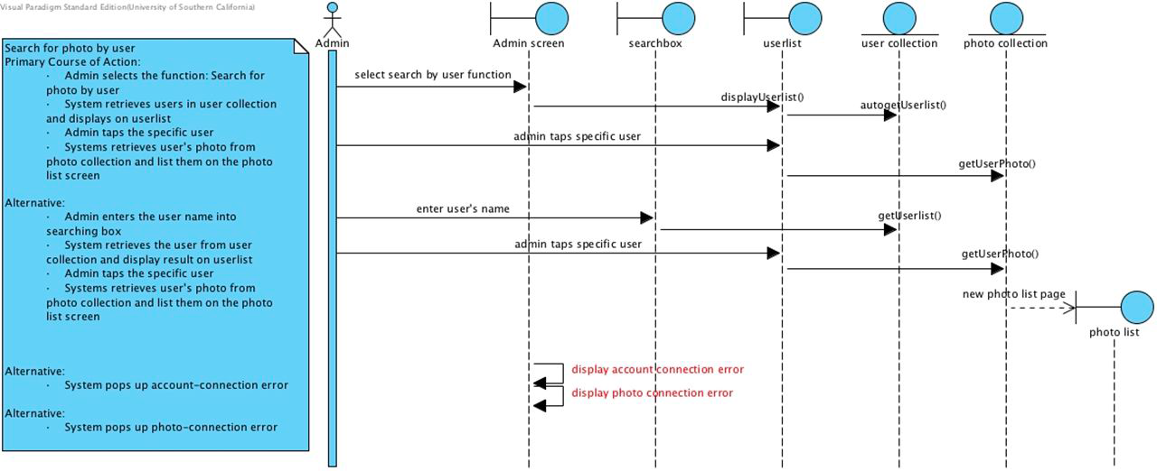

**Use Case: Admin search for photo by event**

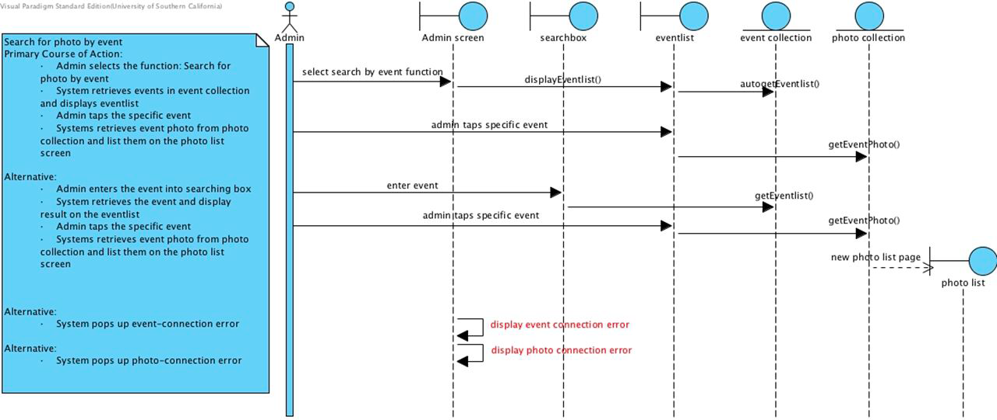

**Use Case: Admin delete photo**

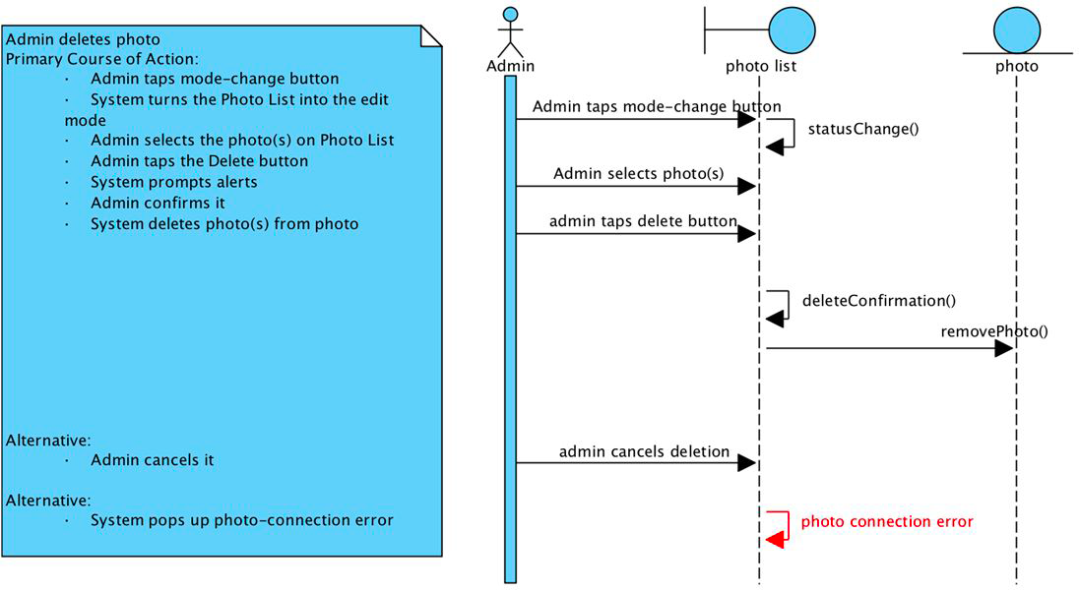

**Use Case: Automatic expiration**

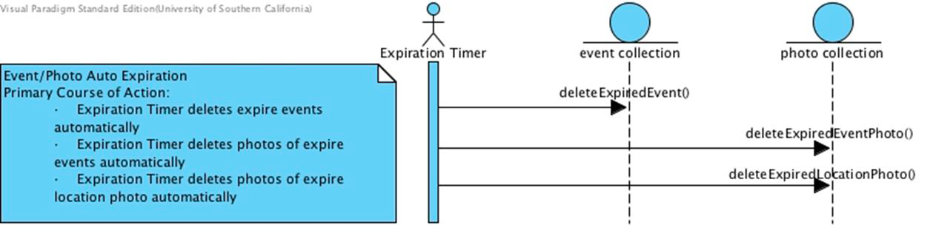

# Deployment diagram

